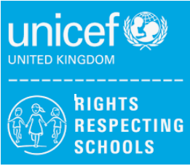
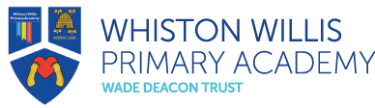
Rights Respecting Schools
March/April 2023 Newsletter

Welcome to our Rights Respecting Schools monthly newsletter! We are currently a Silver Rights Respecting School, working towards becoming Gold. We aim to learn about children’s rights and put them into practice every day. We work towards this goal together with the children, making a positive impact on the whole school community.

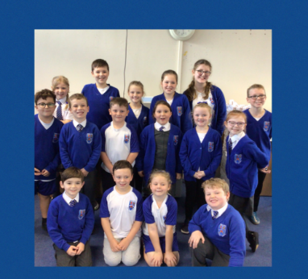
Article of the Month
Each month we will be choosing an article of the month to focus on in assemblies and discussions in class. We hope to widen children’s understanding of their rights and develop their knowledge.

This month our Pupil Leadership Team chose Article 15 – the right to choose your own friendship groups.

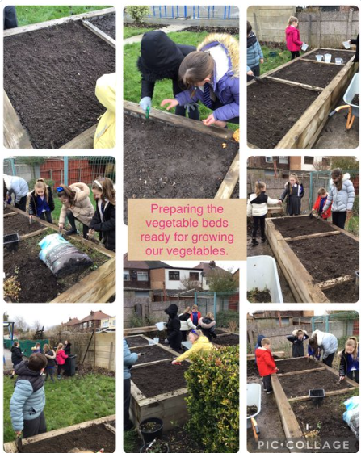
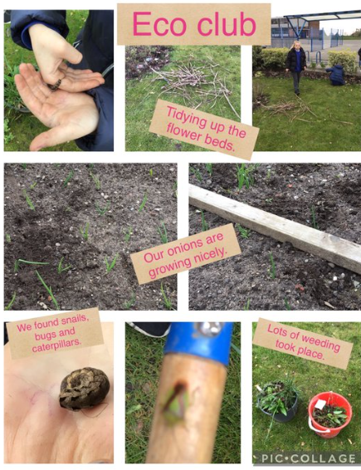
Eco Club
Our Eco Club have been busy preparing our school environment. They have been reducing waste and encouraging biodiversity.
Our garden is looking fantastic after a tidy up, weeding and we found lots of our onions growing nicely!

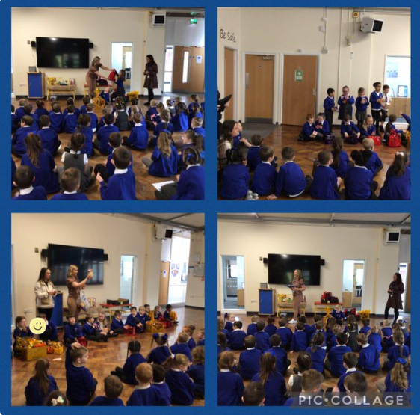

Easter Raffle
What a success our Easter Raffle was! Thank you to every individual who donated Easter eggs, bought raffle tickets and supported our fundraising.
We raised almost £500 which is being donated to UNICEF’s Turkey and Syria Earthquake appeal to support children and young people in their education, wellbeing and general health and nutrition.
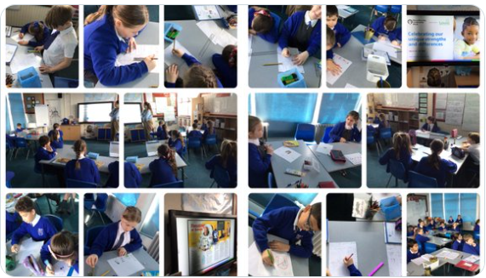
Neurodiversity Celebration Week
We celebrated Neurodiversity Celebration Week to challenge stereotypes and misconceptions about neurological differences. We aim to create a more inclusive environment that celebrates differences and empowers individuals.
Classes looked at neurological differences and made posters to recognise these.

Thank you for your continued support

Mrs A. Askew and the Pupil Leadership Team

