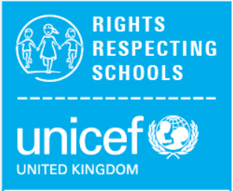
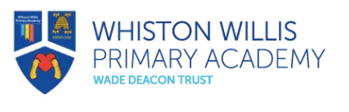

Rights Respecting Schools

As a Rights Respecting school we not only teach about children’s rights but also model the rights and respect in all our relationships. We ensure we put children’s rights into practice every day.
The 4 key areas for impact are:
Children are healthier and happier
Children feel safe
Children have better relationships
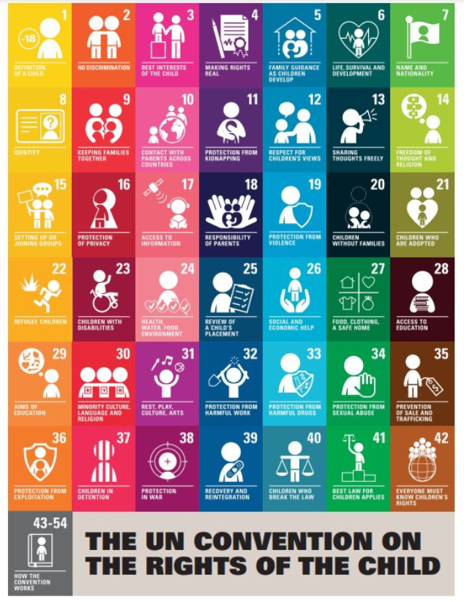
Children become active and involved in school life and the wider world.
What our Pupil Leadership Team have to say…..
‘Children’s voices are important and valued in our school.’
‘We follow and celebrate children’s rights.’
‘We encourage equality.’
‘We are good role models to our younger children.’
‘We have high aspirations.’
‘We want fairness for all!’
ABCDE of Rights!
A – Rights are for ALL children.
B – Rights are there from BIRTH
C – Rights CANNOT be taken away
D – Rights DO NOT have to be earnt.
E – All rights are EQUALLY important.

